WORK IN PROGRESS
Enterprise Retail & Strategic Inventory System
Group 5: Invo6
BSc (Hons) Artificial Intelligence, Level 5
System Development Group Project
The British College, Kathmandu

TEAM MEMBERS
Simona Kattel (24030159)
Sachin Maharjan (24036543)
Pradip Yadav (24036544)
Aayushma Dhakal (24030146)
Abhinav Sitaula (23085179)
Bardan Thapa (23085198)

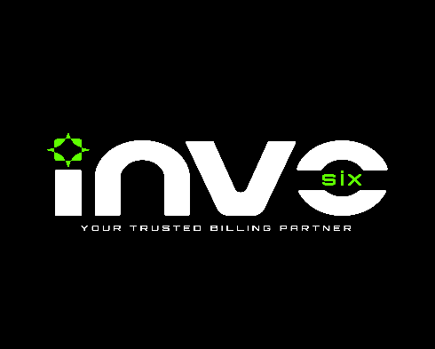
Table of Contents
1. Introduction 3
2. Current Status of the Project 3
3. Progress Made in Each Phase 3
3.1. Initiation Phase 3
3.2. Planning Phase 3
3.3. Execution Phase 4
4. Relevant Screenshots 5
4.1. Wireframe 5
4.2. Project Management (Jira) 11
4.3. Design Artefacts: 12
4.4. Use Case Diagrams 14
4.5. Logo 14
5. Team Meetings 15
6. Conclusion 17

Introduction
Invo6 is a web and mobile-based Enterprise Retail and Strategic Inventory System we are building as our System Development group project. The goal is to give retail shop owners in Nepal a single platform to manage billing, inventory, and sales analytics, replacing handwritten billing with a fast, barcode-driven system that also gives customers access to their own purchase history through a mobile app.
This report covers the work completed up to the Work-In-Progress submission. It explains the current status of the project, the progress made in each phase, screenshots of what is built so far, and the solutions adopted when we ran into problems.

Current Status of the Project
At the time of this WIP submission, the project is on track. The Initiation and Planning phases are fully complete. We are well into the Executing phase, with all design artefacts submitted and active development underway on both the web dashboard and the mobile app.
On the development side, the backend REST API is in progress using FastAPI and MySQL. The React-based web dashboard has its initial layout and authentication flow being built.

Progress Made in Each Phase

Initiation Phase
This phase was about forming a team, agreeing on the problem to solve, and producing the foundation documents that would guide the rest of the project. We identified the pain points of manual billing in Nepalese retail shops and scoped a system that would be affordable and practical for independent stores.
Deliverables completed in this phase:
- Project Title document
- Project Charter
- Team Contract
- Risk Register

Planning Phase
In this phase, we focused on understanding the team's strengths, setting up collaboration tools, and designing the workflow we would follow during development.
Deliverables completed in this phase:
- Belbin Analysis: Each member completed the test, and roles are chosen based on natural team strengths.
- Skill Audit: Individual and combined team audits are used to identify gaps and decide who handles what area.
- Communication Tool: Discord for regular meetings, GitHub for version control and code collaboration, Email for formal communication, and Google Drive for file storage, sharing, and collaboration document management.
- Project Management (Jira): Workspace created and initial setup done, team is beginning to use it for task tracking as development ramps up.

Execution Phase
This is the phase we are currently in, and it carries the most weight. It is split into two parts: design artefacts and product development.
Design Artefacts (complete):
- Use Case Diagrams: Separate diagrams for Customer, Cashier, and Admin roles, plus a combined overview diagram.
- ERD: Basic ERD, EERD, final composite/de-composite ERD, and logical table.
- Wireframes: Full wireframe set for both the React Native mobile app and the React web dashboard, covering all major screens.
- Logo: Two logos are designed for Invo6.
- Requirement Catalogue: The functional requirements include product and inventory management, customer features, shopkeeper/admin features, billing and transactions, AI and analytics, IoT integration, authentication and security, and store administration. The non-functional requirements define the system’s performance, usability, reliability, and security standards.
Product Development (in progress):

We are following Agile Scrum tracked in Jira. Development is ongoing across the following areas:
- Backend (FastAPI + MySQL): core models defined, REST API endpoints for products, inventory, billing sessions, transactions, and user management in progress. JWT auth, bcrypt hashing, and email OTP 2FA implemented.
- IoT Integration (ESP32 + MQTT): barcode scanner module integrated, ESP32 publishes scan events to the backend via MQTT, which updates the active billing session in real time via WebSocket.
- Web Dashboard (React): authentication flow (login, register, 2FA, forgot password) and main dashboard layout built.
- Mobile App (React Native): onboarding carousel, authentication screens, and customer transaction history dashboard built and connected to the backend.
- AI Module: sales forecasting regression model and RAG-based chatbot (using FAISS vector database and sentence embeddings) in development.
- Docker Compose: containerization configuration in progress for one-command deployment.

Project Management:

We have set up Jira as our project management tool and are in the early stages of using it. The workspace has been created, and we are beginning to log tasks as development ramps up. Alongside Jira, we have held 12 documented team meetings on Discord and in class to coordinate work, review submissions, and align on next steps. GitHub is used for version control with a clear branching strategy (main/develop/feature/*).

Relevant Screenshots
The original files are in the Executing folder of this submission.

Wireframe
Only some wireframe screenshots are shown here. The rest can be found in the wireframe folder.

Web Dashboard for Admin:

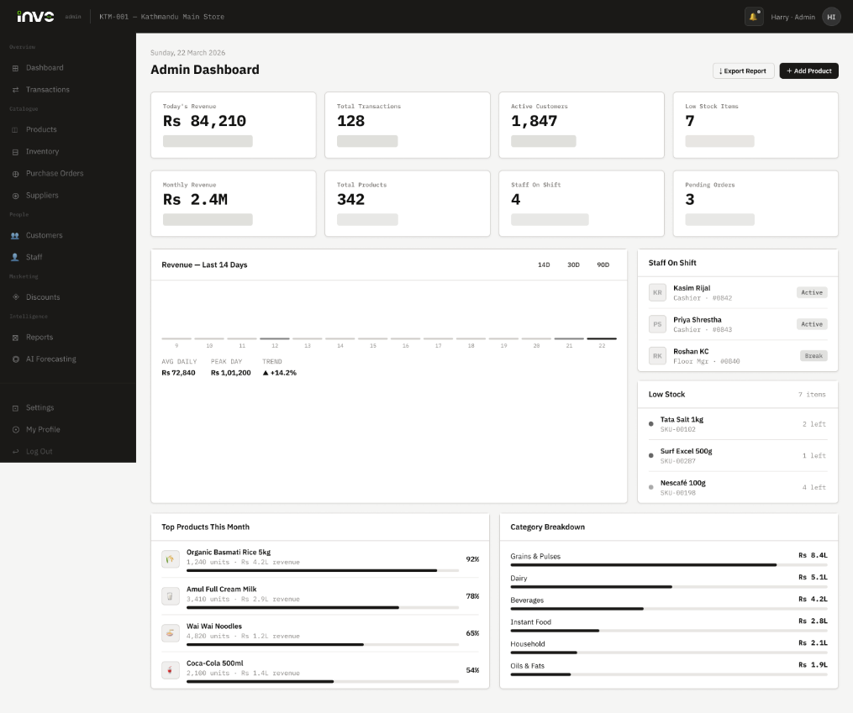
Admin Dashboard Page

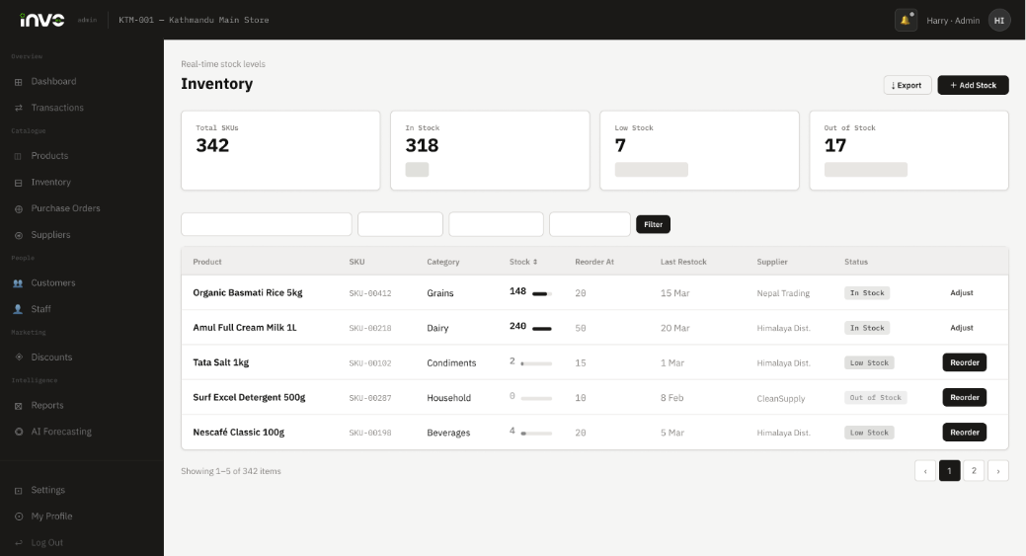
Admin Inventory Page

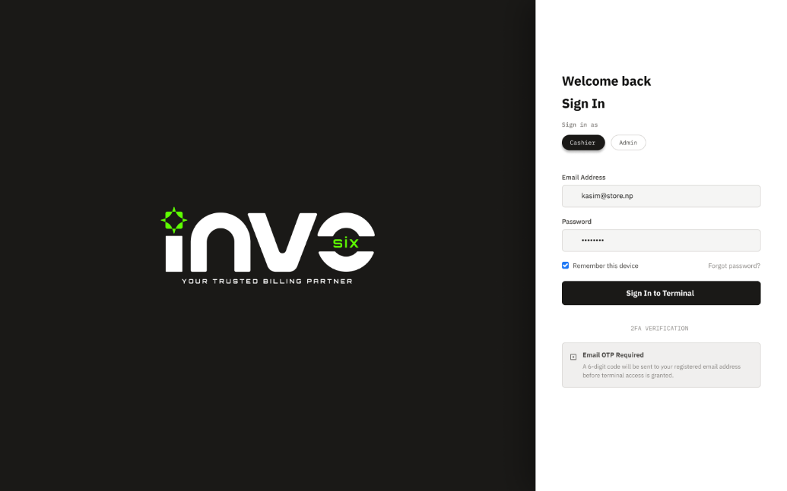
Admin Login page

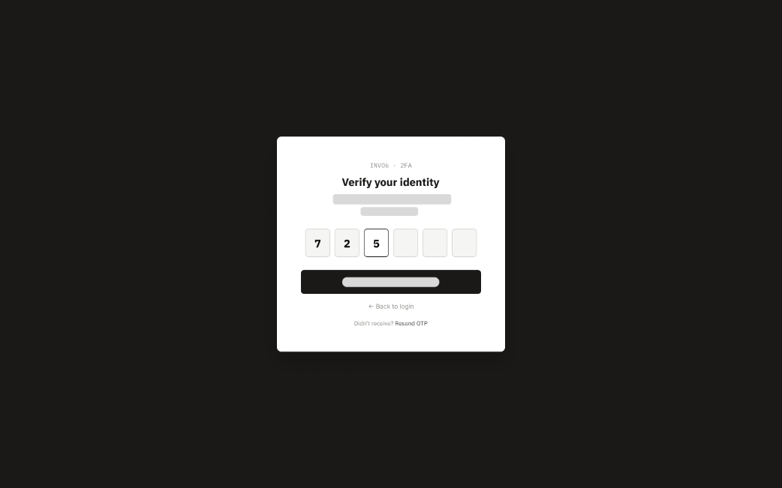
OTP Verification Page

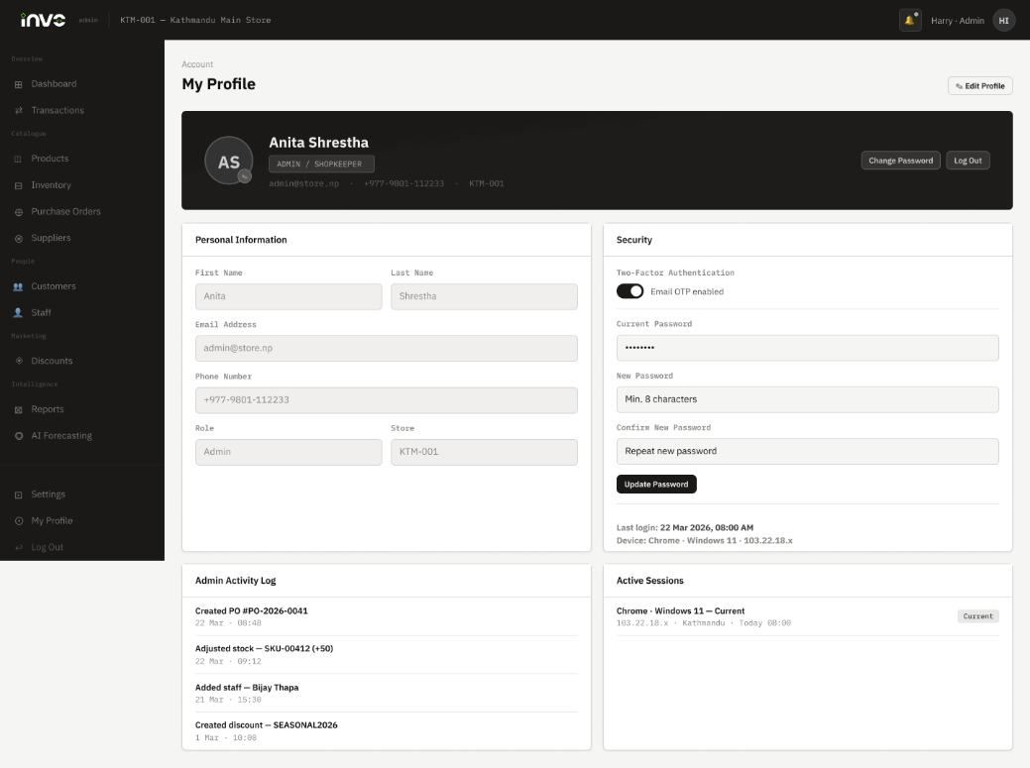
Admin Profile Page

Web Dashboard for Cashier:

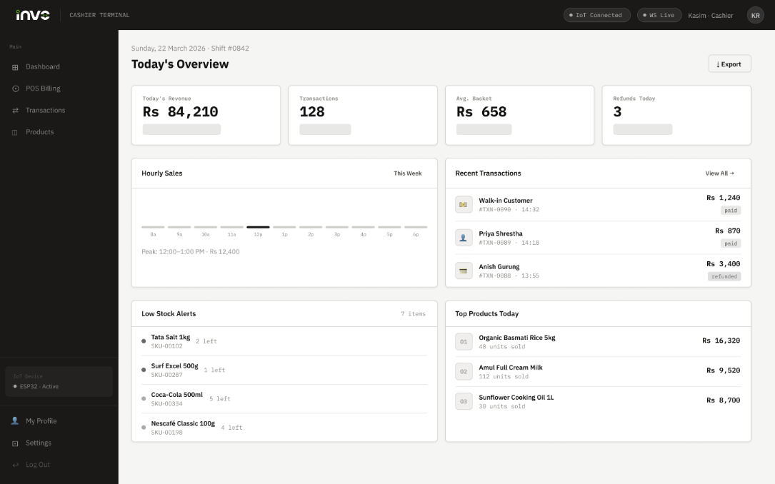
Cashier Dashboard Page

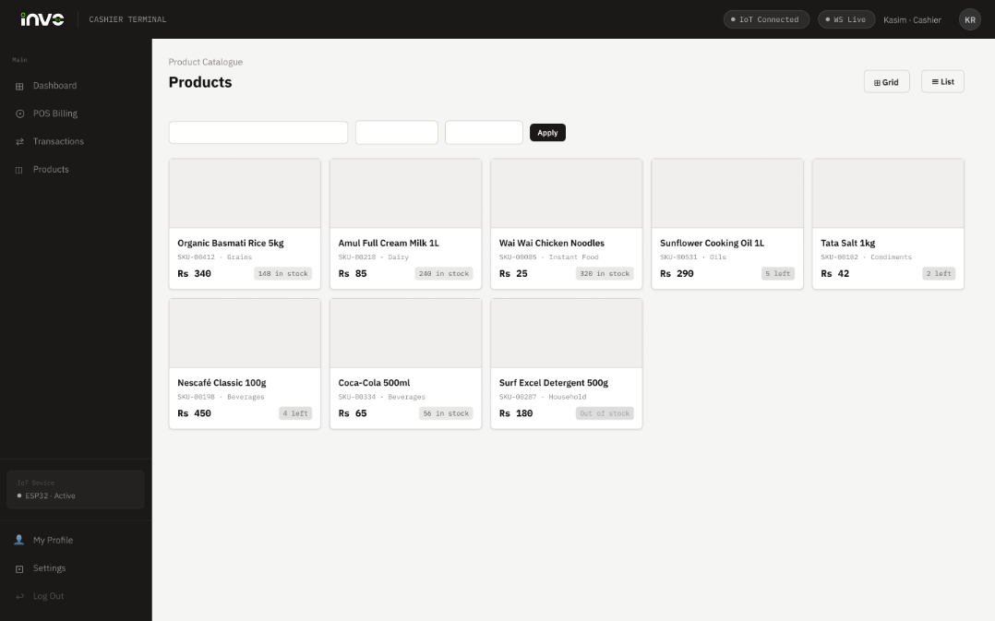
Cashier Products Page

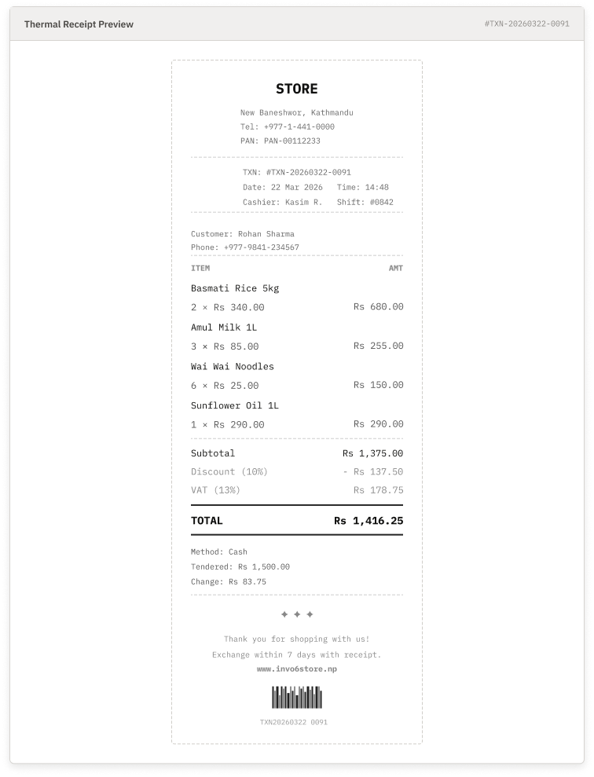
Receipt Preview

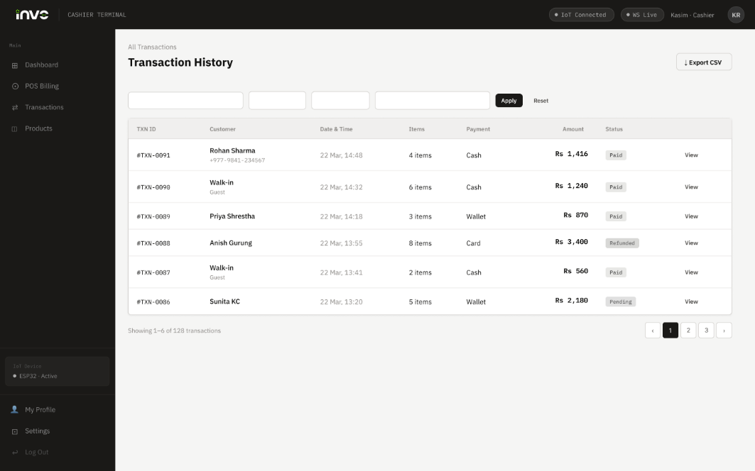
Transaction History Page

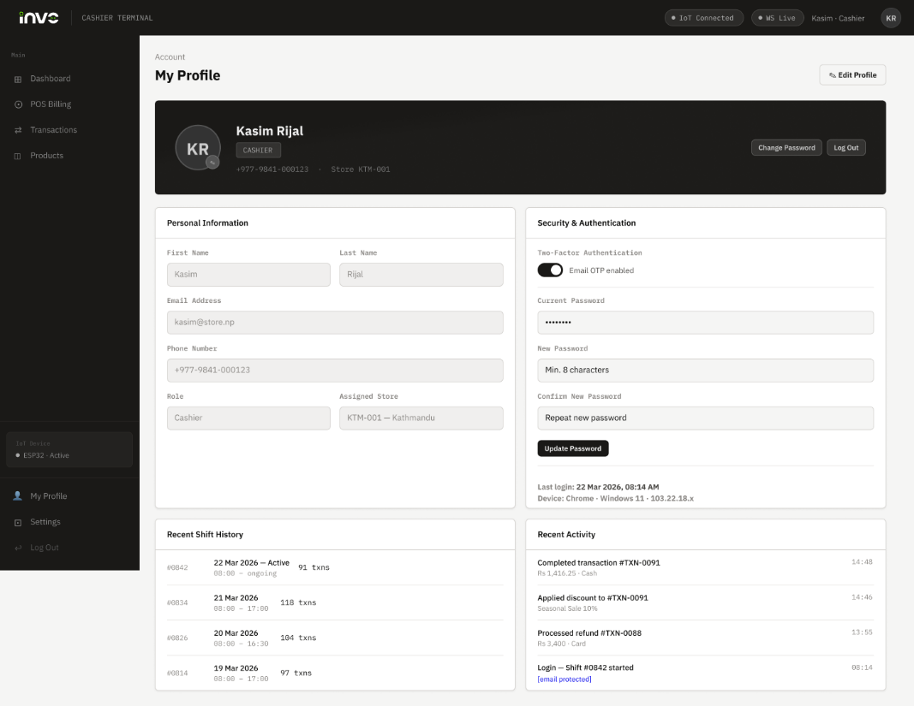
Cashier Profile Page

Mobile App for Customer:

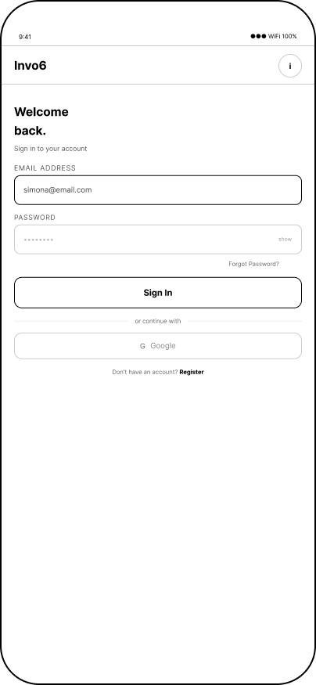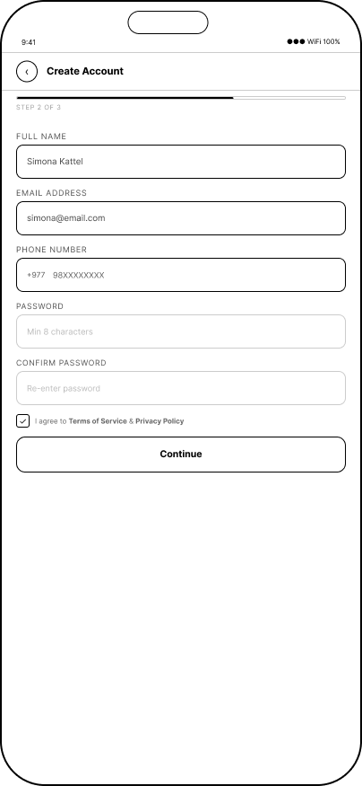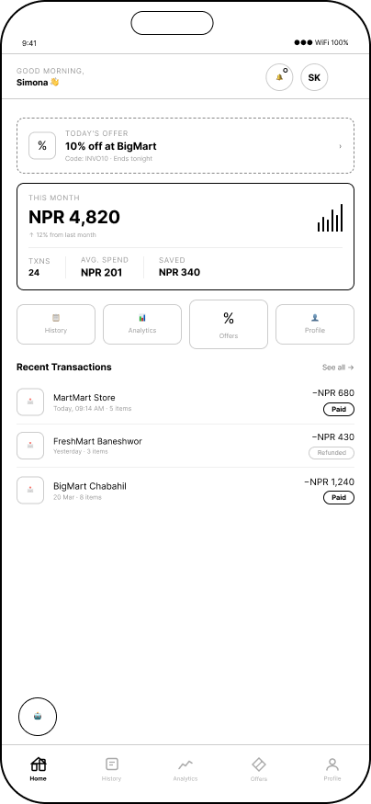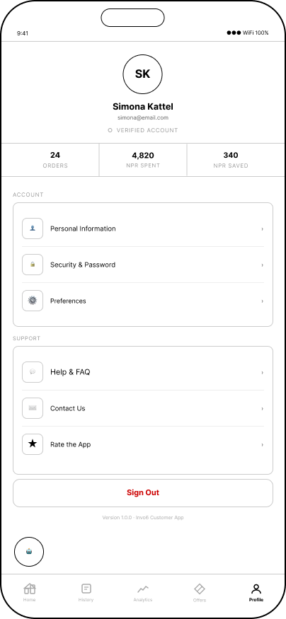

Project Management (Jira)
Jira has been set up as our project management tool. We are in the early stages of populating it with tasks. Below is a screenshot of the current workspace setup.
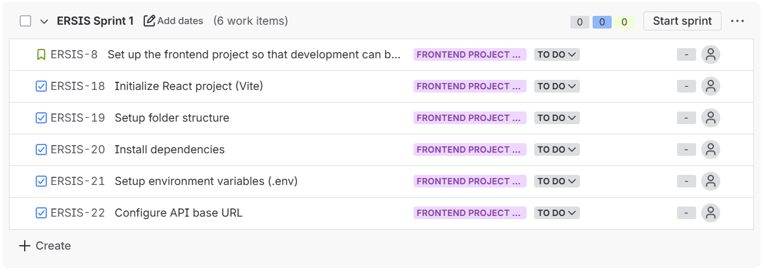
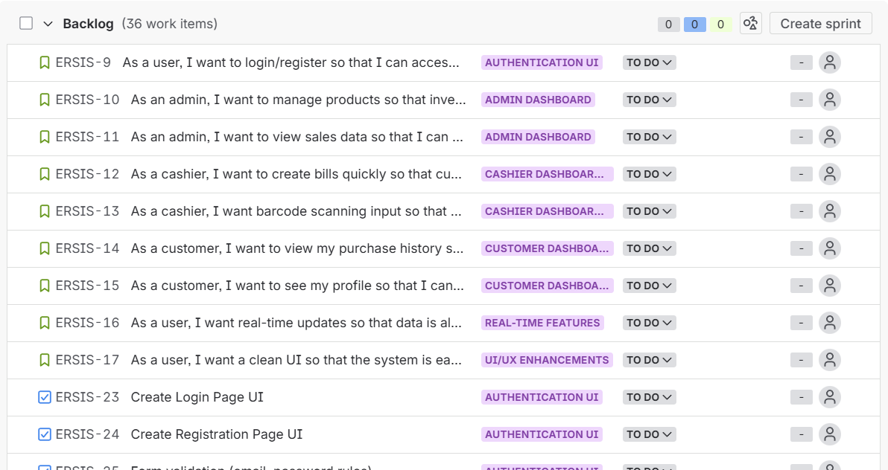

Design Artefacts:

Entity Relationship Diagrams:

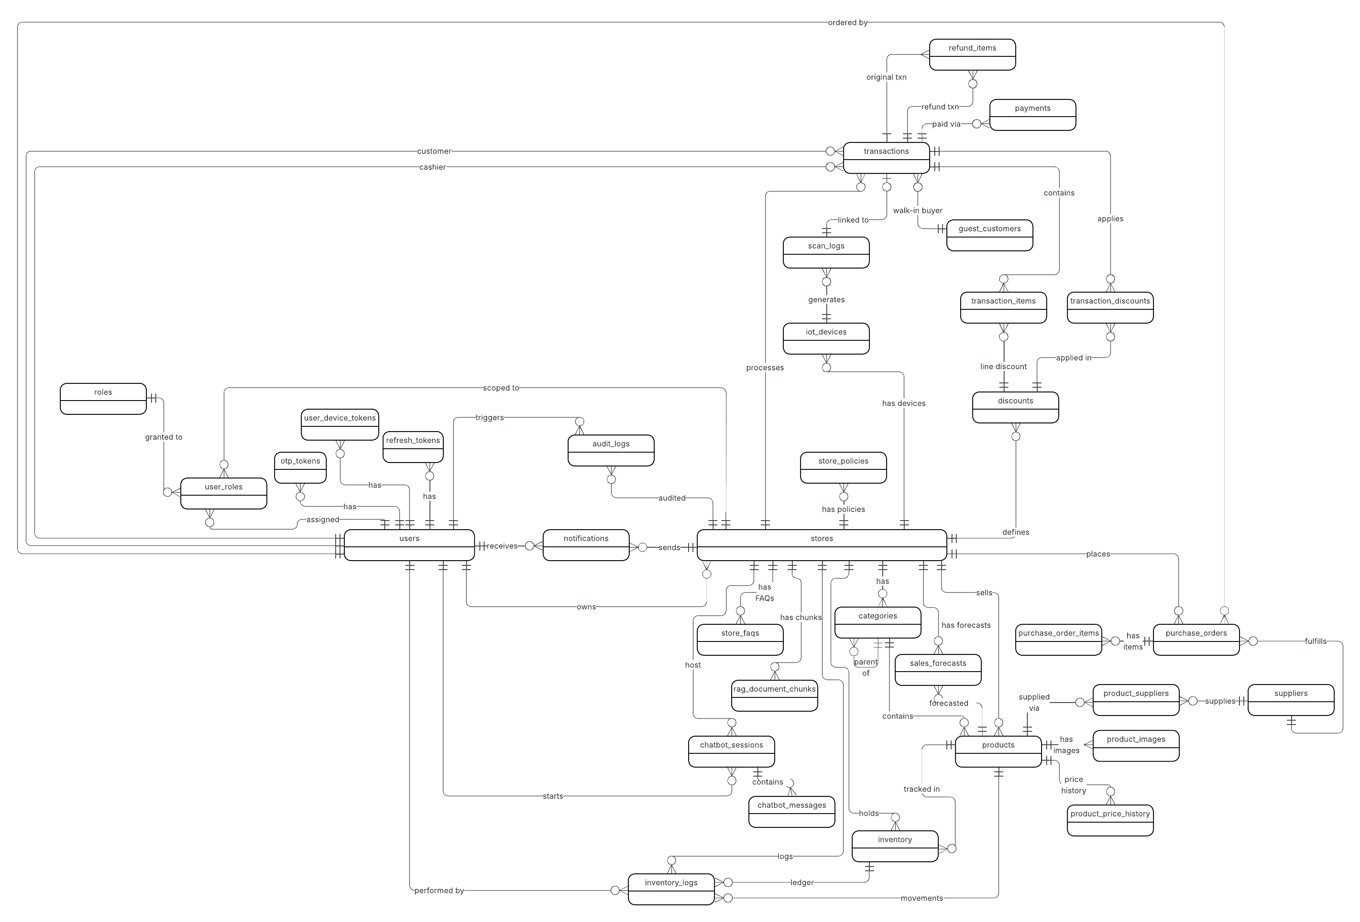
Entity Relationship Diagram

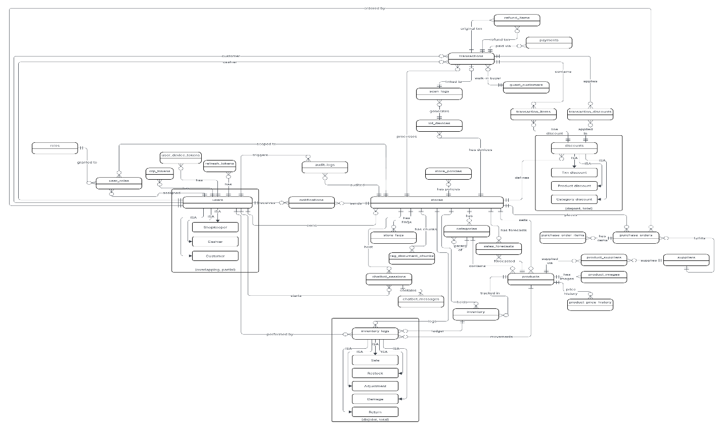
Enhanced Entity Relationship Diagram

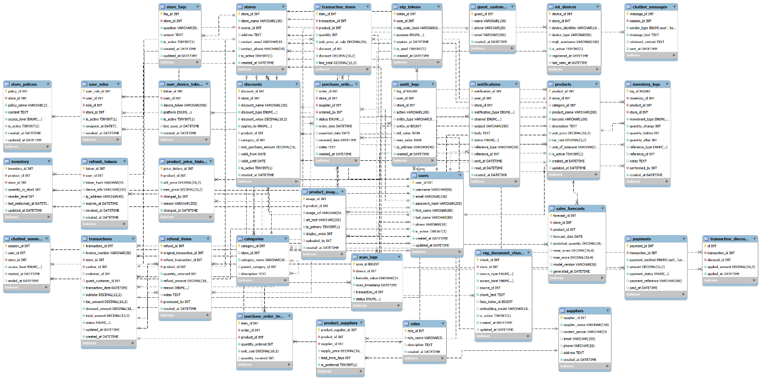
Final De-composite ERD

Use Case Diagrams
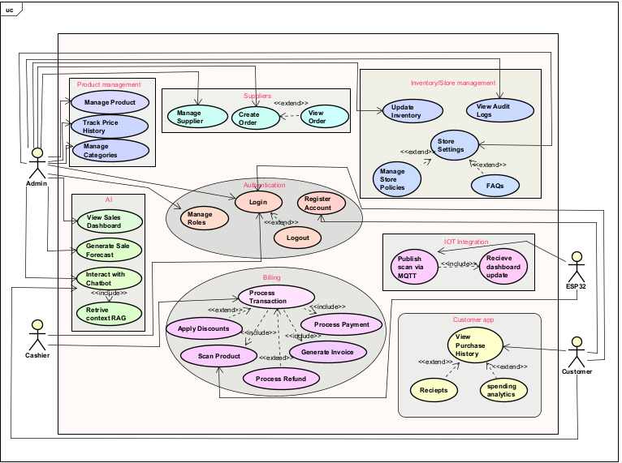
Overview (All Actors)

Logo


Logo 1

Logo 2

Team Meetings
Regular team meetings were conducted to ensure alignment, track progress, and address challenges throughout the project.
Meeting 1
- Date: 21/02/2026
- Objective: Initial team introduction and project discussion.
- Discussion Points:
  - Introduction of all team members
  - Overview of the project
  - Discussion on individual contributions and roles
- Meeting Image:
Meeting 2
- Date: 22/02/2026
- Objective: Quick project alignment
- Discussion Points:
  - Short discussion on project direction
  - Clarification of initial ideas
Meeting 3
- Date: 24/02/2026
- Objective: Project planning and documentation
- Discussion Points:
  - Team contract submission
  - Project charter discussion
Meeting 4
- Date: 11/03/2026
- Objective: Team structure and idea development
- Discussion Points:
  - Skill audit discussion
  - Team contract review
  - Logo design ideas
  - Belbin analysis
  - Overall project concepts
Meeting 5
- Date: 14/03/2026
- Objective: Team identity and role assignment
- Discussion Points:
  - Finalization of group name
  - Skill audit discussion
  - Assignment of roles and responsibilities
Meeting 6
- Date: 18/03/2026
- Objective: Submission review
- Discussion Points:
  - Belbin analysis submission
Meeting 7
- Date: 20/03/2026
- Objective: Design and submission planning
- Discussion Points:
  - Submission requirements
  - Wireframe discussion
Meeting 8
- Date: 21/03/2026
- Objective: Design refinement
- Discussion Points:
  - Continued wireframe discussions
  - Feedback and improvements
Meeting 9
- Date: 2/04/2026
- Objective: Development progress discussion
- Discussion Points:
  - Git clone process discussion
  - Work-in-progress submission updates
  - Coordination on ongoing development tasks
Meeting 10
- Date: 04/04/2026
- Objective: Review of project progress and version control coordination
- Discussion Points:
  - Working progress updates from team members
  - GitHub usage and collaboration discussion
  - Coordination on code integration and repository management
Meeting 11
- Date: 05/04/2026
- Objective: Submission of project requirements
- Discussion Points:
  - Requirement catalogue submission
  - Final review of documented requirements
  - Clarifications and feedback on submission
Meeting 12
- Date: 09/04/2026
- Objective: Review of ongoing development progress
- Discussion Points:
  - Updates on current working progress
  - Discussion of completed and pending tasks
  - Coordination on next steps and task distribution

Conclusion
The Invo6 system is progressing as planned, with all initiation and planning activities completed and development actively underway. Key design artefacts have been finalized, and core system components, including backend, web dashboard, mobile app, and IoT integration, are in development. The team is effectively collaborating using Agile practices and project management tools. Overall, the project is on track to deliver a practical, efficient, and scalable retail and inventory solution for Nepalese shop owners.

